Task 3. Build a VPC with Public & Private Subnets
Goal: Deploy infrastructure using networking best practices. Tasks:
· Create a VPC with 2 public and 2 private subnets.
· Configure route tables and Internet Gateway for public subnets.
· Set up a NAT Gateway for private subnets.
· Launch a public Bastion Host (EC2).
· Launch a private EC2 instance and connect to it through the Bastion using SSH.

- Create vpc
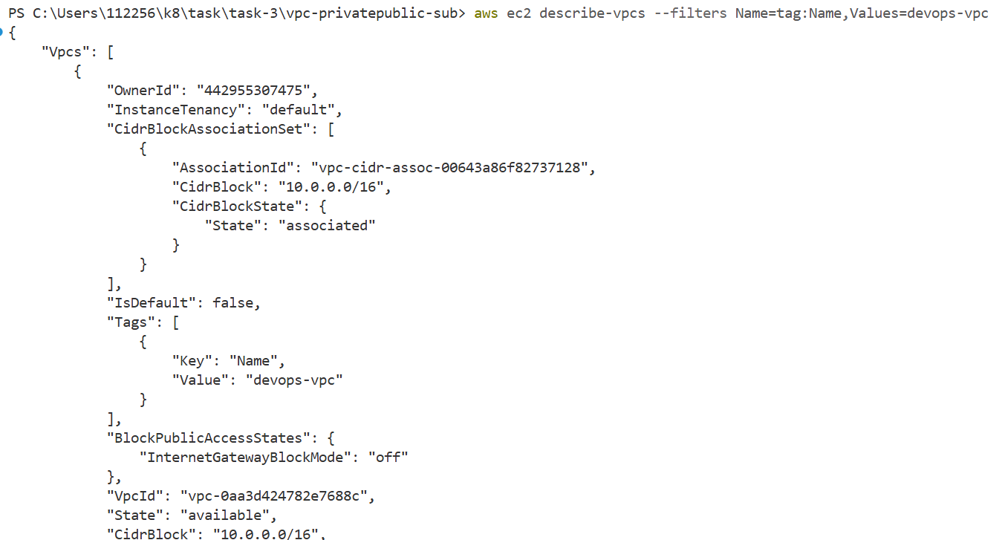

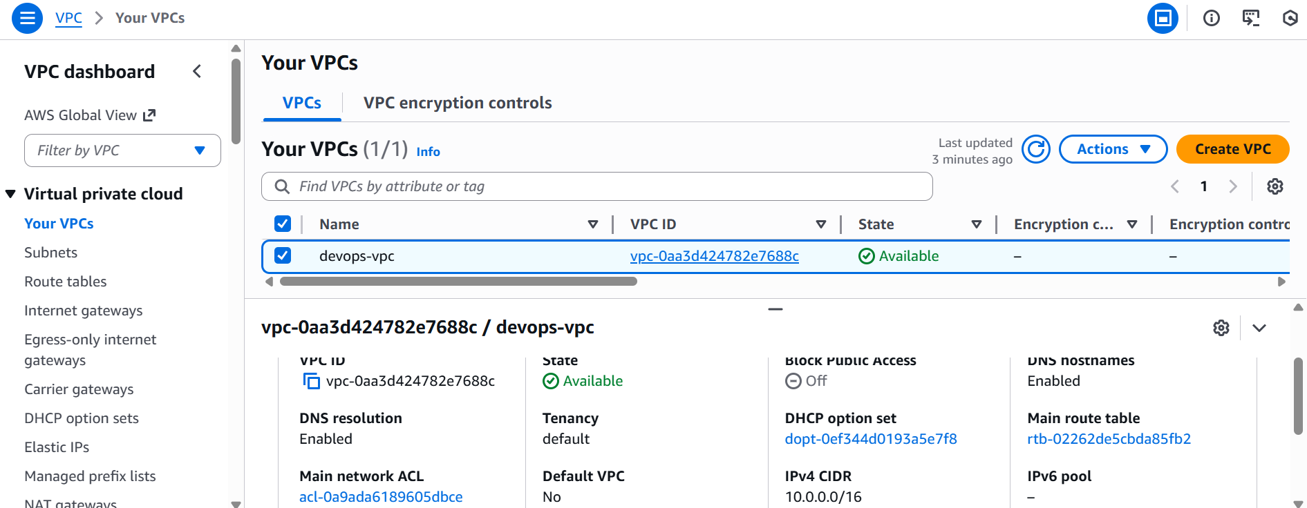

2. Create public and private subnet
-Public subnets → internet-facing resources
- Private subnets → internal workloads

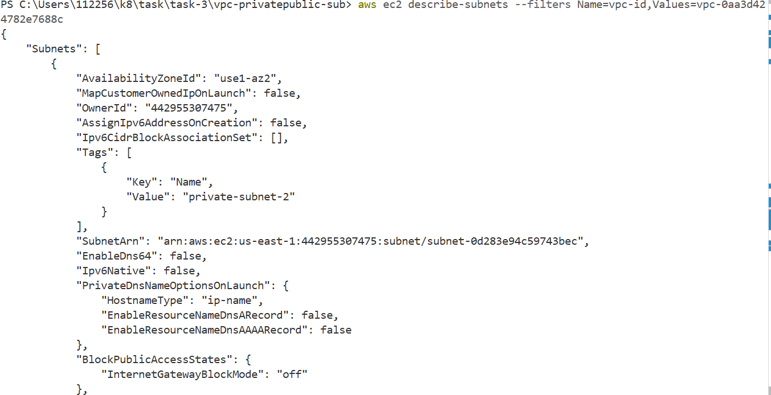

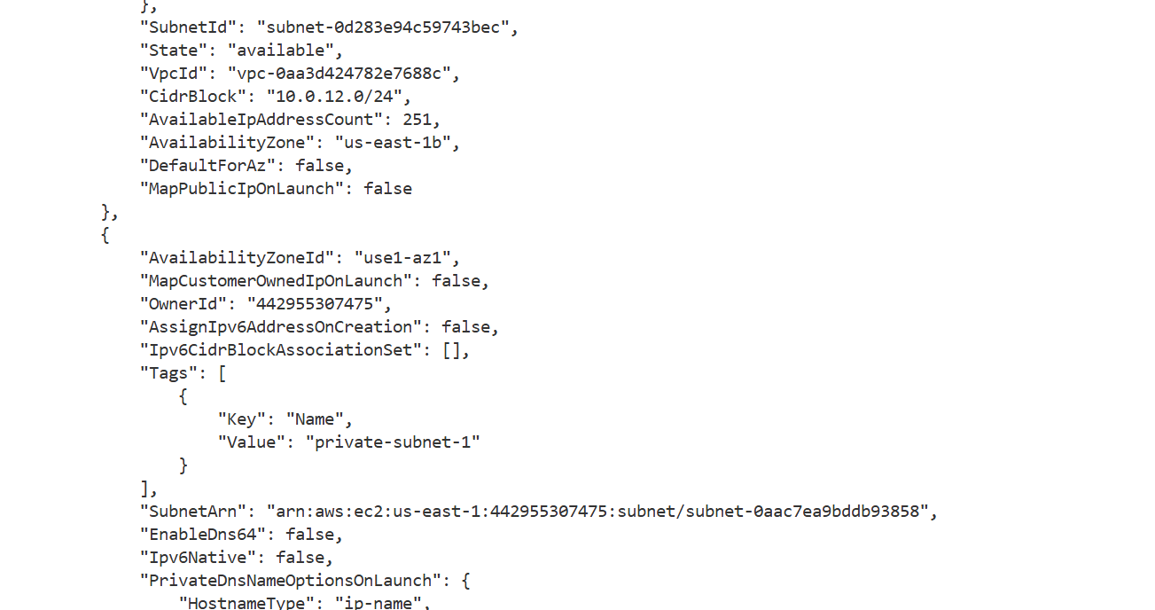
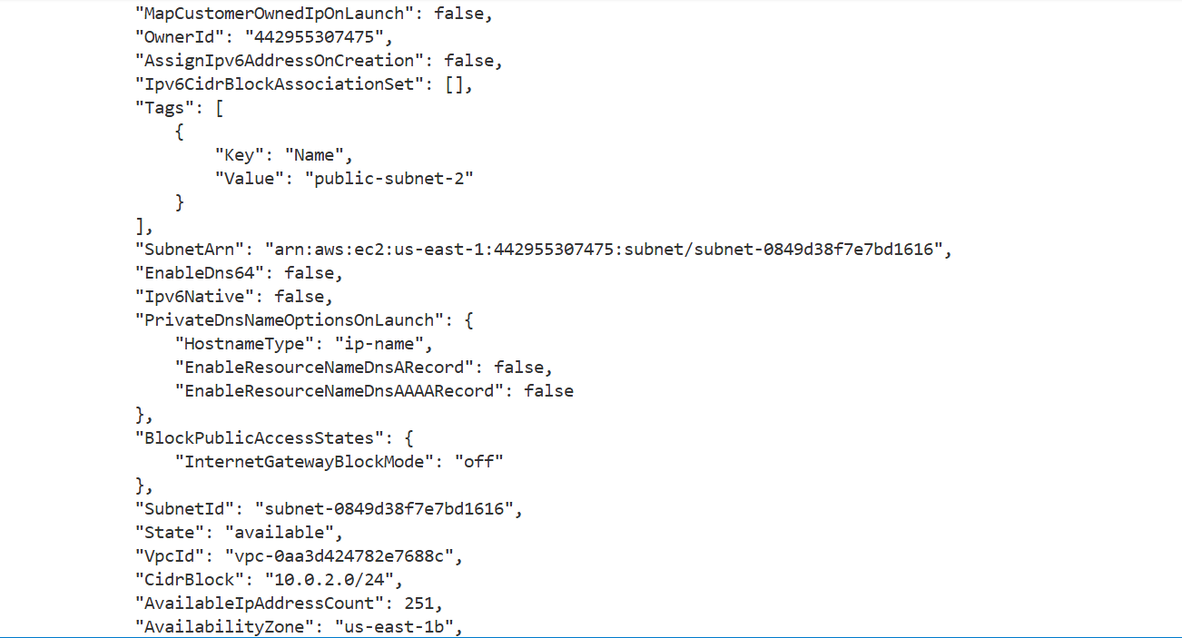
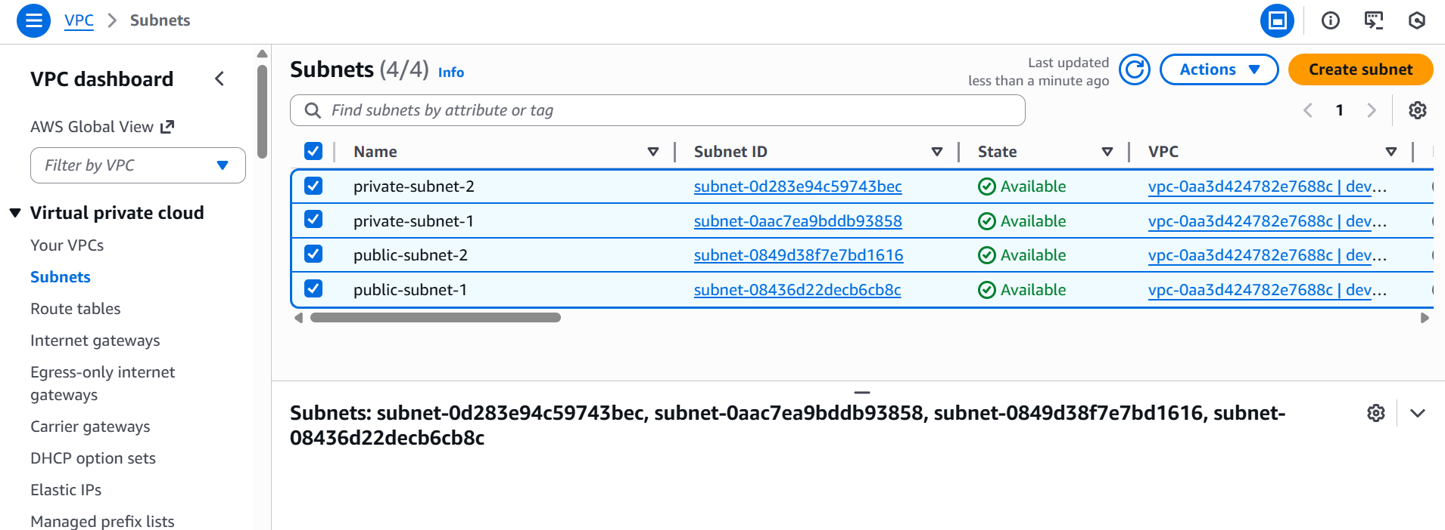

3.Configure route tables and Internet Gateway for public subnets.
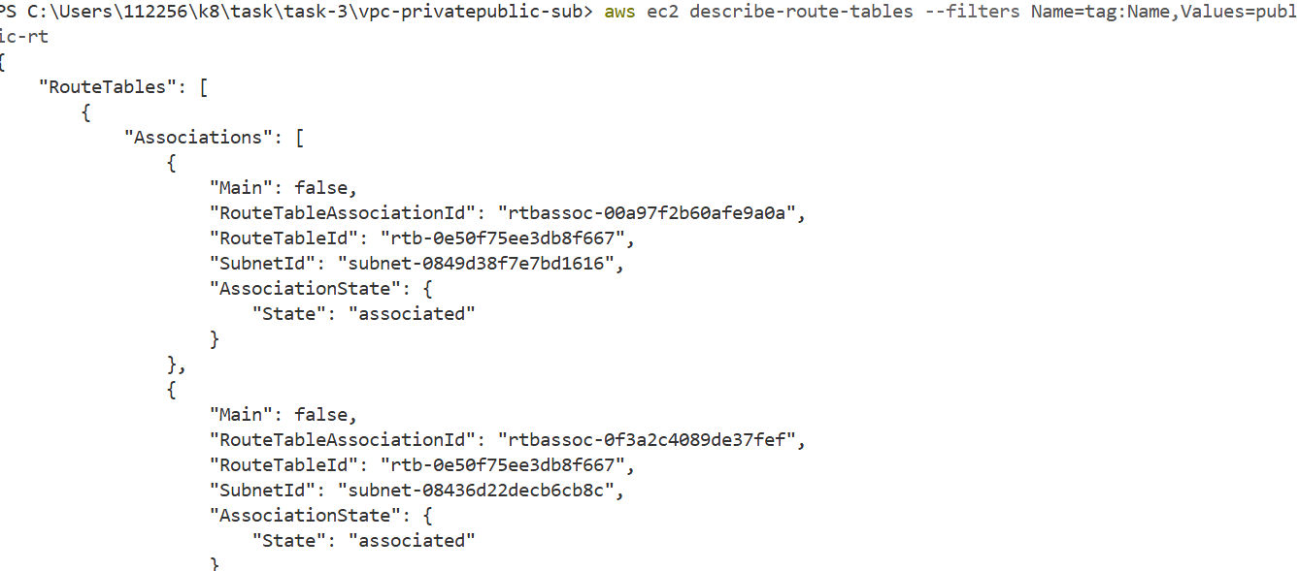

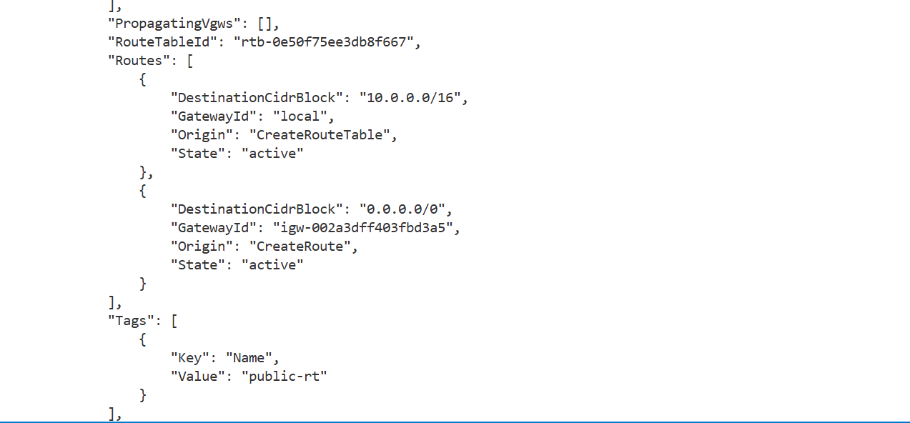

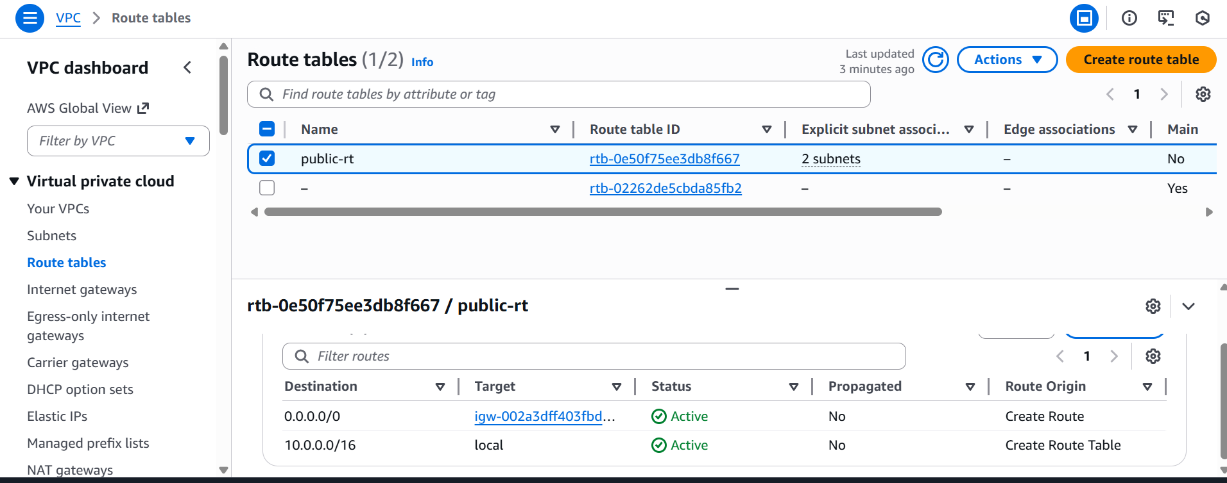

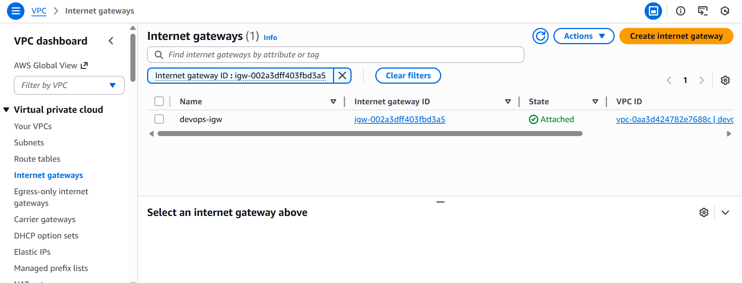

4. Set up a NAT Gateway for private subnets.

Use - Private instances need outbound internet access securely.
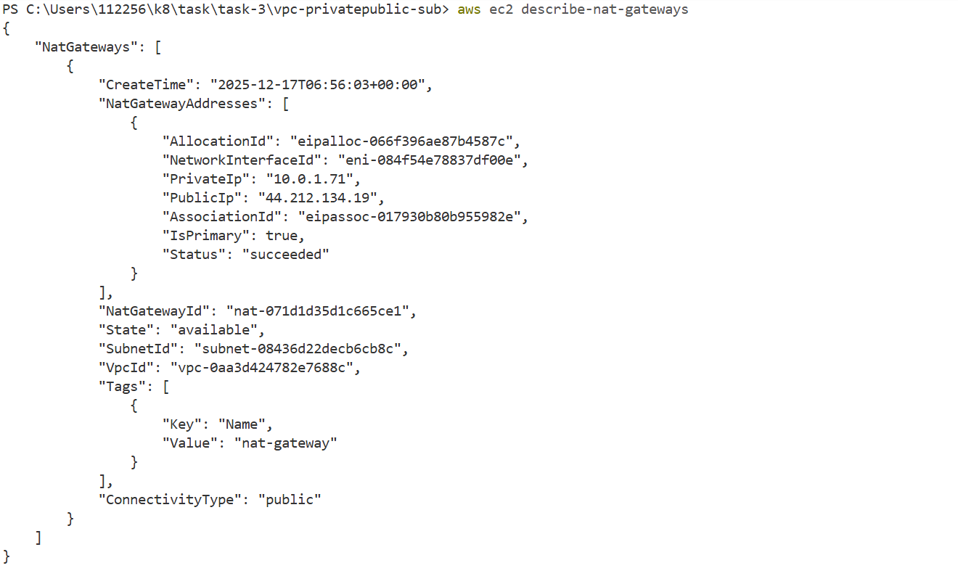

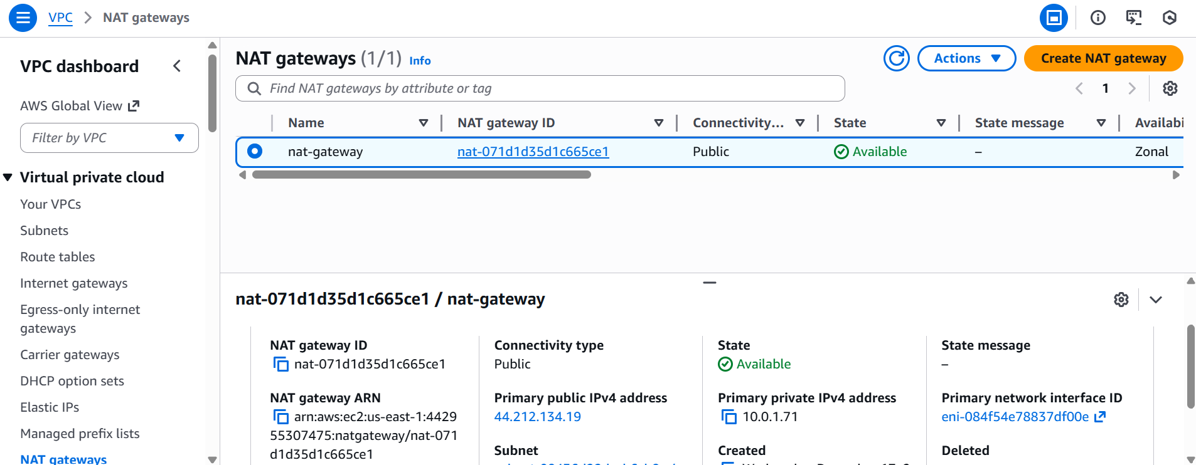

5.Launch a public Bastion Host (EC2).

- Use for - Single secure SSH entry point.

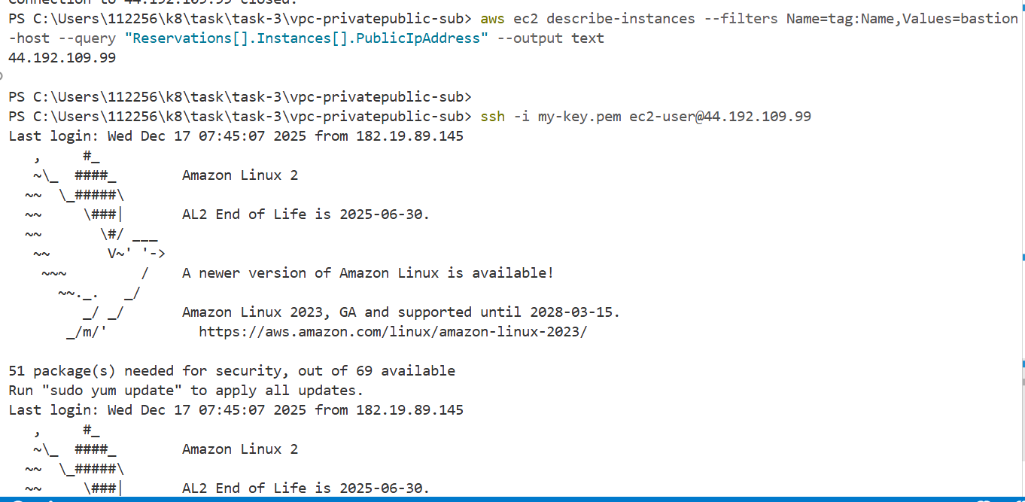

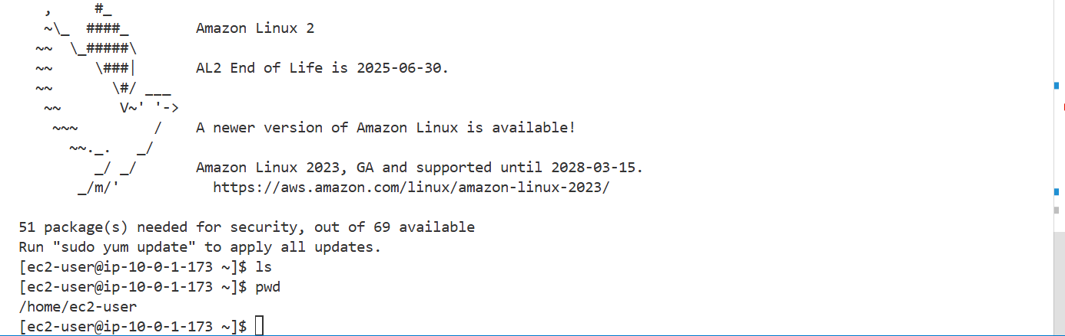
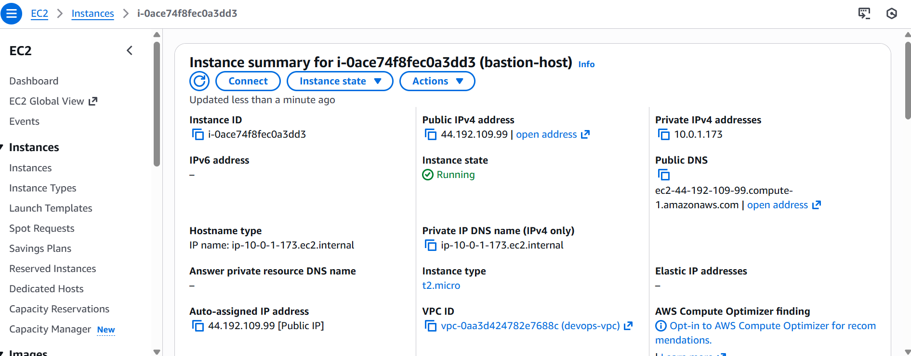

6.Launch a private EC2 instance and connect to it through the Bastion using SSH.

